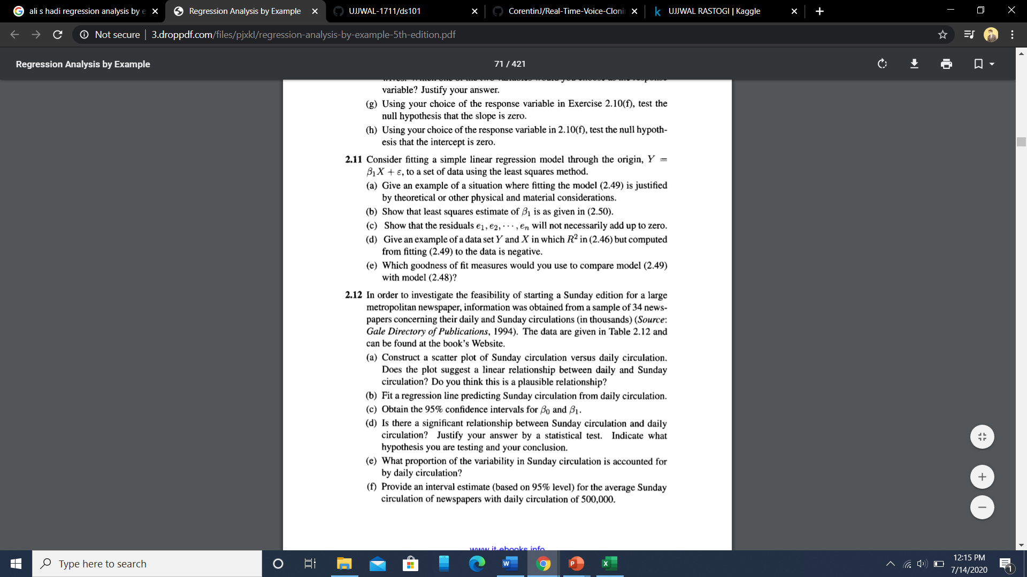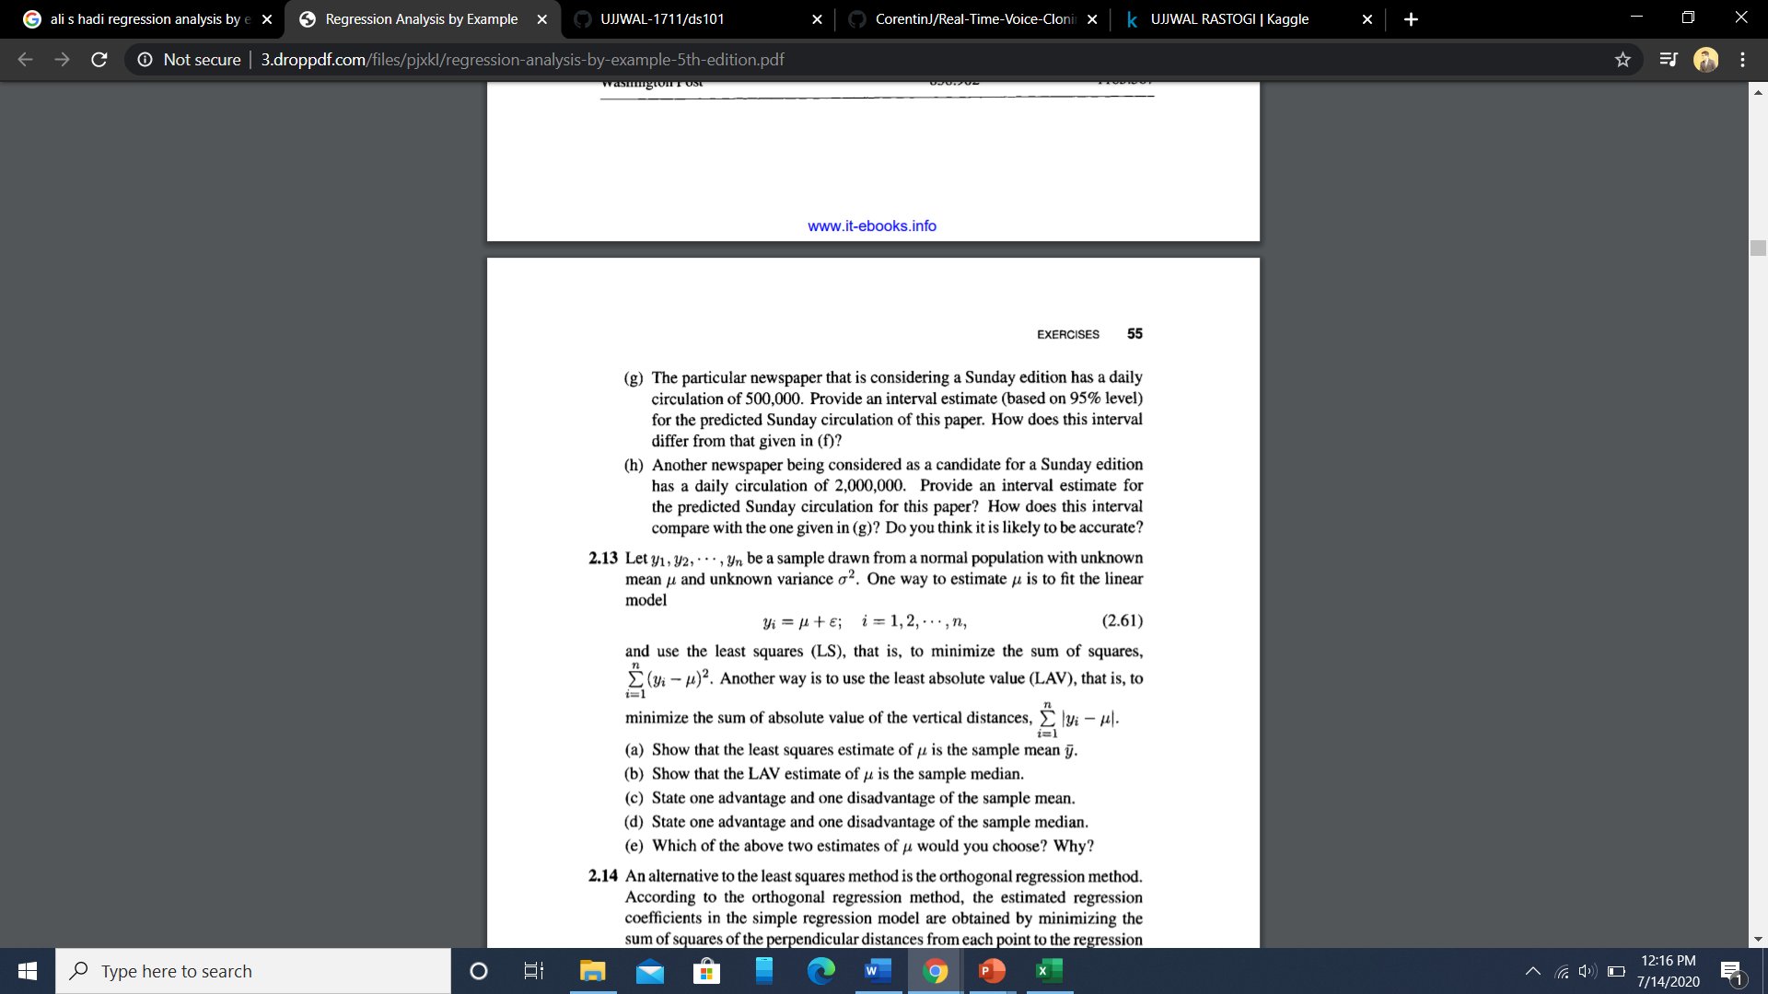

<https://colab.research.google.com/drive/1dGQTApMS2Q-NyFSfpGf5dMy6nMTQ0QeA?usp=sharing>

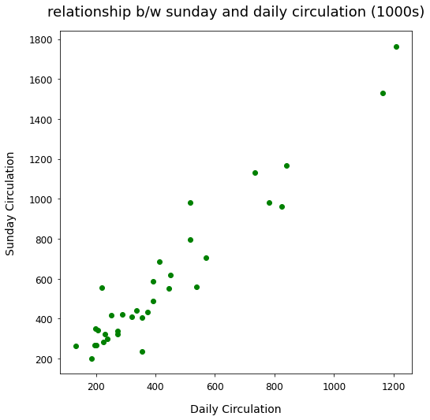

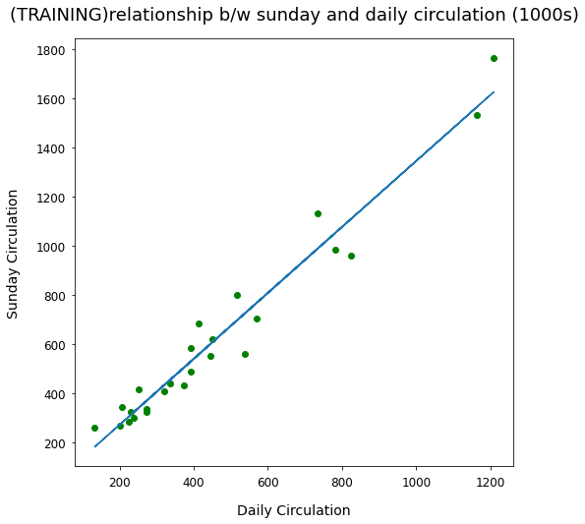

Using XL Miner ToolPak:

|  |  |  |  |
| --- | --- | --- | --- |
| Coefficients | Standard Error | t Stat | P-value |
| 15.73042161 | 36.48324843 | 0.431168339 | 0.669329551 |
| 1.338866654 | 0.071663149 | 18.68277728 | 1.98937E-18 |

Range of b0 and b1 with 95% confidence

|  |  |
| --- | --- |
| 0 | 31.46084 |
| 0 | 2.677733 |

High linear relationship

|  |  |
| --- | --- |
| R Square | 0.918430963 |

Since the observation of 2mil for daily circulation is unprecedented in the training data henceforth the prediction upon it will be unreliable as the linear relationship is bound to a very precise area